
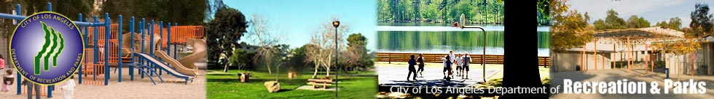
The San Fernando Valley Community Presents:
The Authentic Job Fair! Come find your future
You are invited to participate as an employer in our event on September 27th at Sylmar recreational center in Sylmar, CA. This event is being sponsored by Goodwill Southern California, Independent Living Center, Sylmar Neighborhood Partnership, and Sylmar Recreational Center. Please RSVP to bmanila@goodwillsocal.org Fax: (818) 908-5827 or gcastro@ilcsc.org Fax: (818) 994-5515

Goodwill Southern California, Independent Living Center, Sylmar Neighborhood Partnership and Sylmar Recreational Center have planned this special event for the communities of the San Fernando Valley.

Goodwill Southern California enhances the dignity and quality of life of individuals, families and communities by eliminating barriers to job opportunity and helping people in need reach their fullest potential through the power of work.

For over 34 years the ILCSC has been assisting people with disabilities to gain the skills they need to reach new levels of independence in life through ILCSC services. The ILCSC services include: Assistive Technology, Emergency Services, Personal Assistant Referrals, Homemaker Training, Vocational Training, Computer Skills, Independent Living Skills, Job Placement, and Job Coaching Services

The Sylmar Neighborhood Partnership is a community collaborative that reaches out to already existing community partners, integrates them into the Sylmar High School culture, and as a result supports students, families, community members, and teachers. Put simply, it takes a village to raise a child, and we’re trying to work together as that village.

We are requesting you to participate in”the Authentic Job Fair” held at Sylmar Recreational Center, 13109 Borden Ave Sylmar, CA 91342

Complete the information below for your contact person. PLEASE BE AWARE THAT POSITIONS MUST BE AVAILABLE AS THIS IS A JOB FAIR THAT MUST PROVIDE REAL OPPORTUNITIES.

Employer:___________________________________________________________________________

Types and number of positions available:________________________________________________

Address: ___________________________________________________________________________

City: State: Zip:______________________________________________________________________

Phone: ______________________________________ Fax:___________________________________

E-mail: _____________________________________________________________________________
Number of staff members attending the job fair:___________________________________________
Employer check- In Time Monday at 11:00 a.m. to 11:30 a.m.

Application form – fully completed by September 17th 2010, signed, dated and email or faxed to:

Brenda Manila bmanila@goodwillsocal.org Fax: (818) 908-5827
OR
Gabriela Castro gcastro@ilcsc.org Fax: (818) 994-5515

ATTN: “The Authentic Job Fair”
I have read and understand this agreement, and will comply with all provisions and policies stated herein.

Signature__________________________Title___________________________Date_________

Please contact our office at 818-908--1199 EXT 103 Gabriela Castro or Brenda Manila (818) 908-5820 EXT 201
For more information about the Job Fair

Employer Registration information:
Goodwill Southern California, Independent Living Center, Sylmar Neighborhood Partnership, and Sylmar Recreational center will be hosting a job fair this year. We will be offering employers the opportunity to obtain table space(s) at the event. Space is limited and will be awarded to employers who complete and submit all required registration forms. This event will focus on providing the community with employment opportunities, as we will be offering employers on site interview space. If you are interested in obtaining a table please fill out the registration form, and submit it as soon as possible. The dates, times, and locations are as follows:

“Our First Community Job Fair” Employer RULES
TERMS & CONDITIONS:
- Job Fair Hours are Monday September, 27th from12 pm to 4:30 pm. Set up time is from 11 am until 11:30 am.
- Staff will be on hand to provide space assignments and general assistance.
- Surrounding area is to be kept clean at all times.
- Employers are solely responsible for the security of their tables and property.
- Register early- this will be an indoor even only, and space will be limited to 30 employers.

